Intro to Computer Graphics - Project 1

**Progress Report**

**By Jose Marquez**

Part 2 - Results:

Successfully created and rendered multiple triangles using JavaScript and WebGL. I had initially started using the WebGL tutorial on drawing a single triangle, which was a big help in getting started on this project.

Implemented a color attribute, and the colors change randomly when clicking the canvas, which was very challenging but also interesting because I thought it was a cool interactive feature. Learned how to use vertex, color, and index buffers to render geometry (still a bit confusing).

Considering the size of the code, debugging was a challenge for sure, typos, and I also faced redundant as well as repetitive calls that overrode previous calls for the triangles.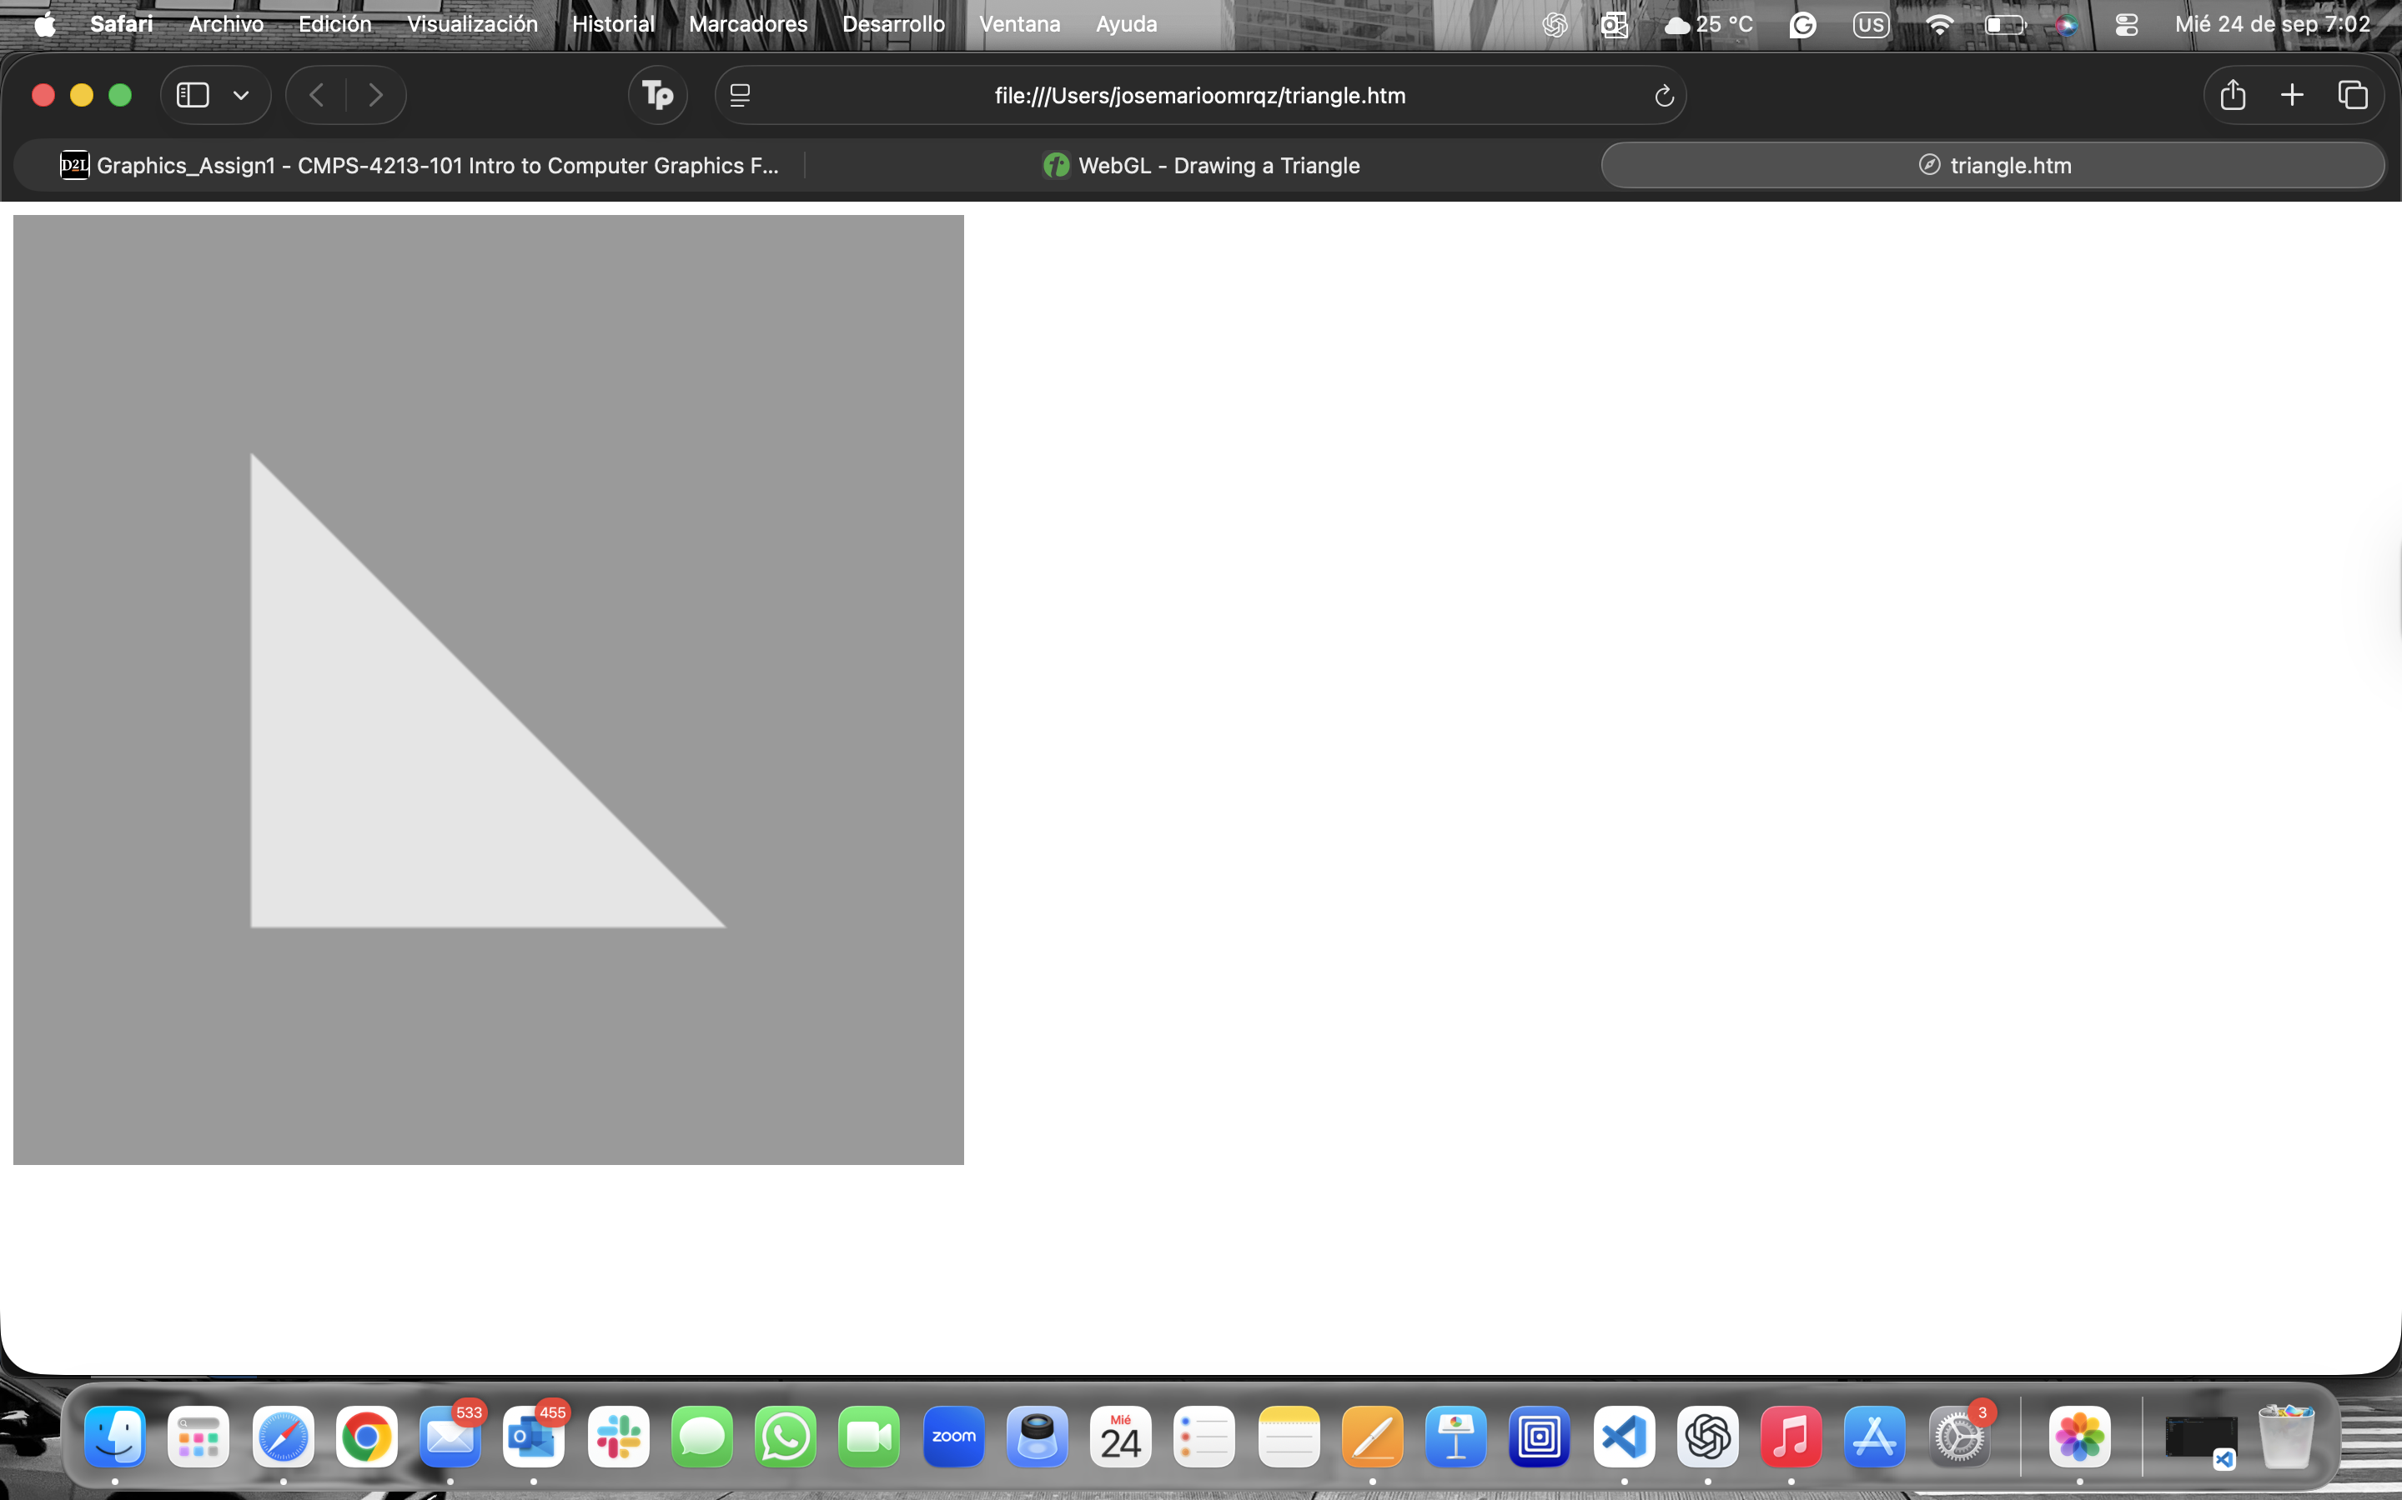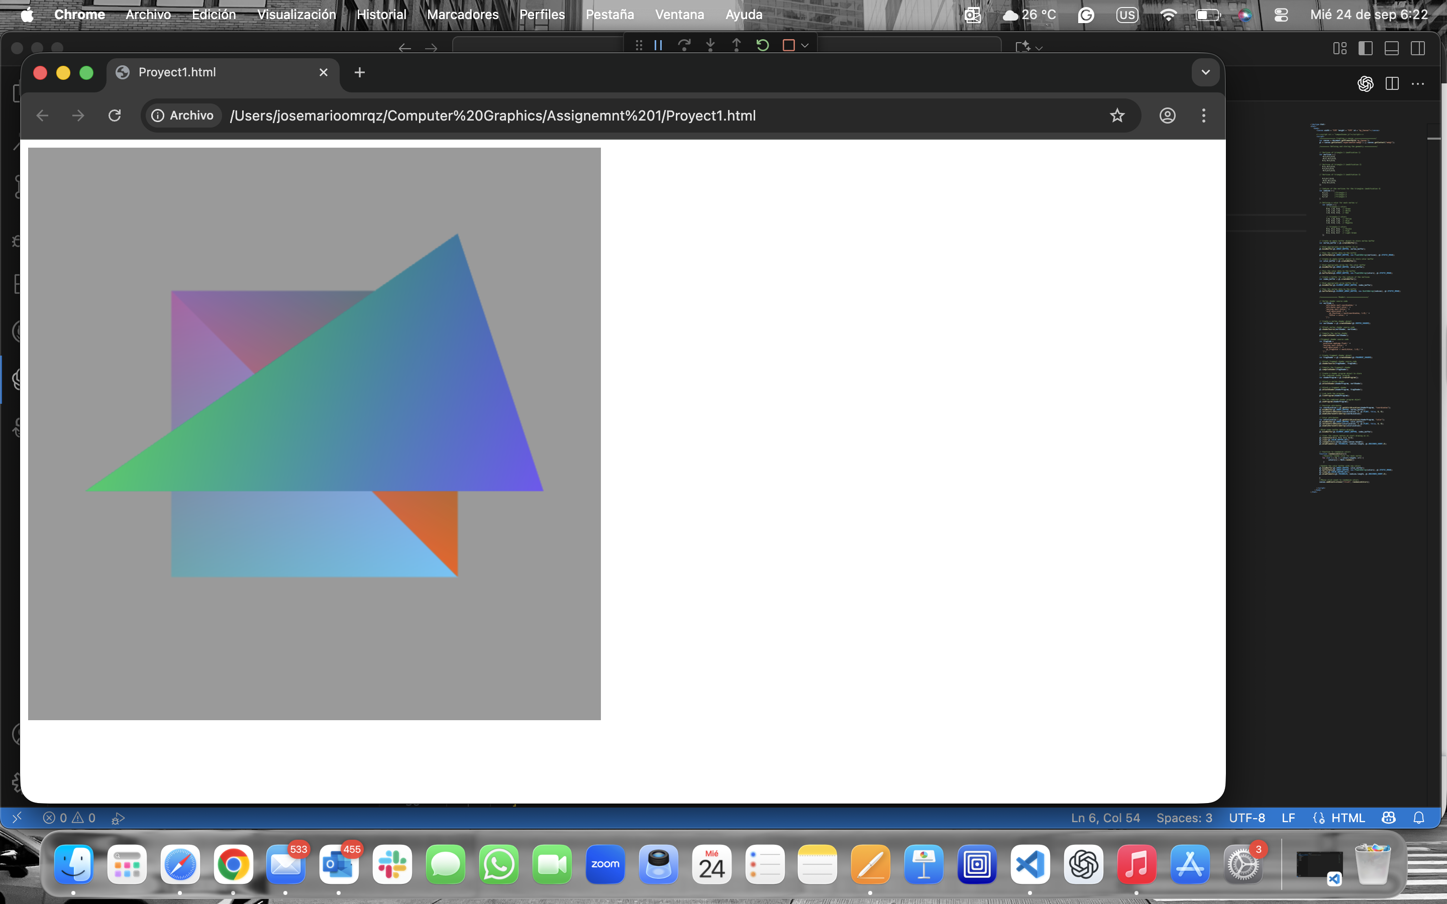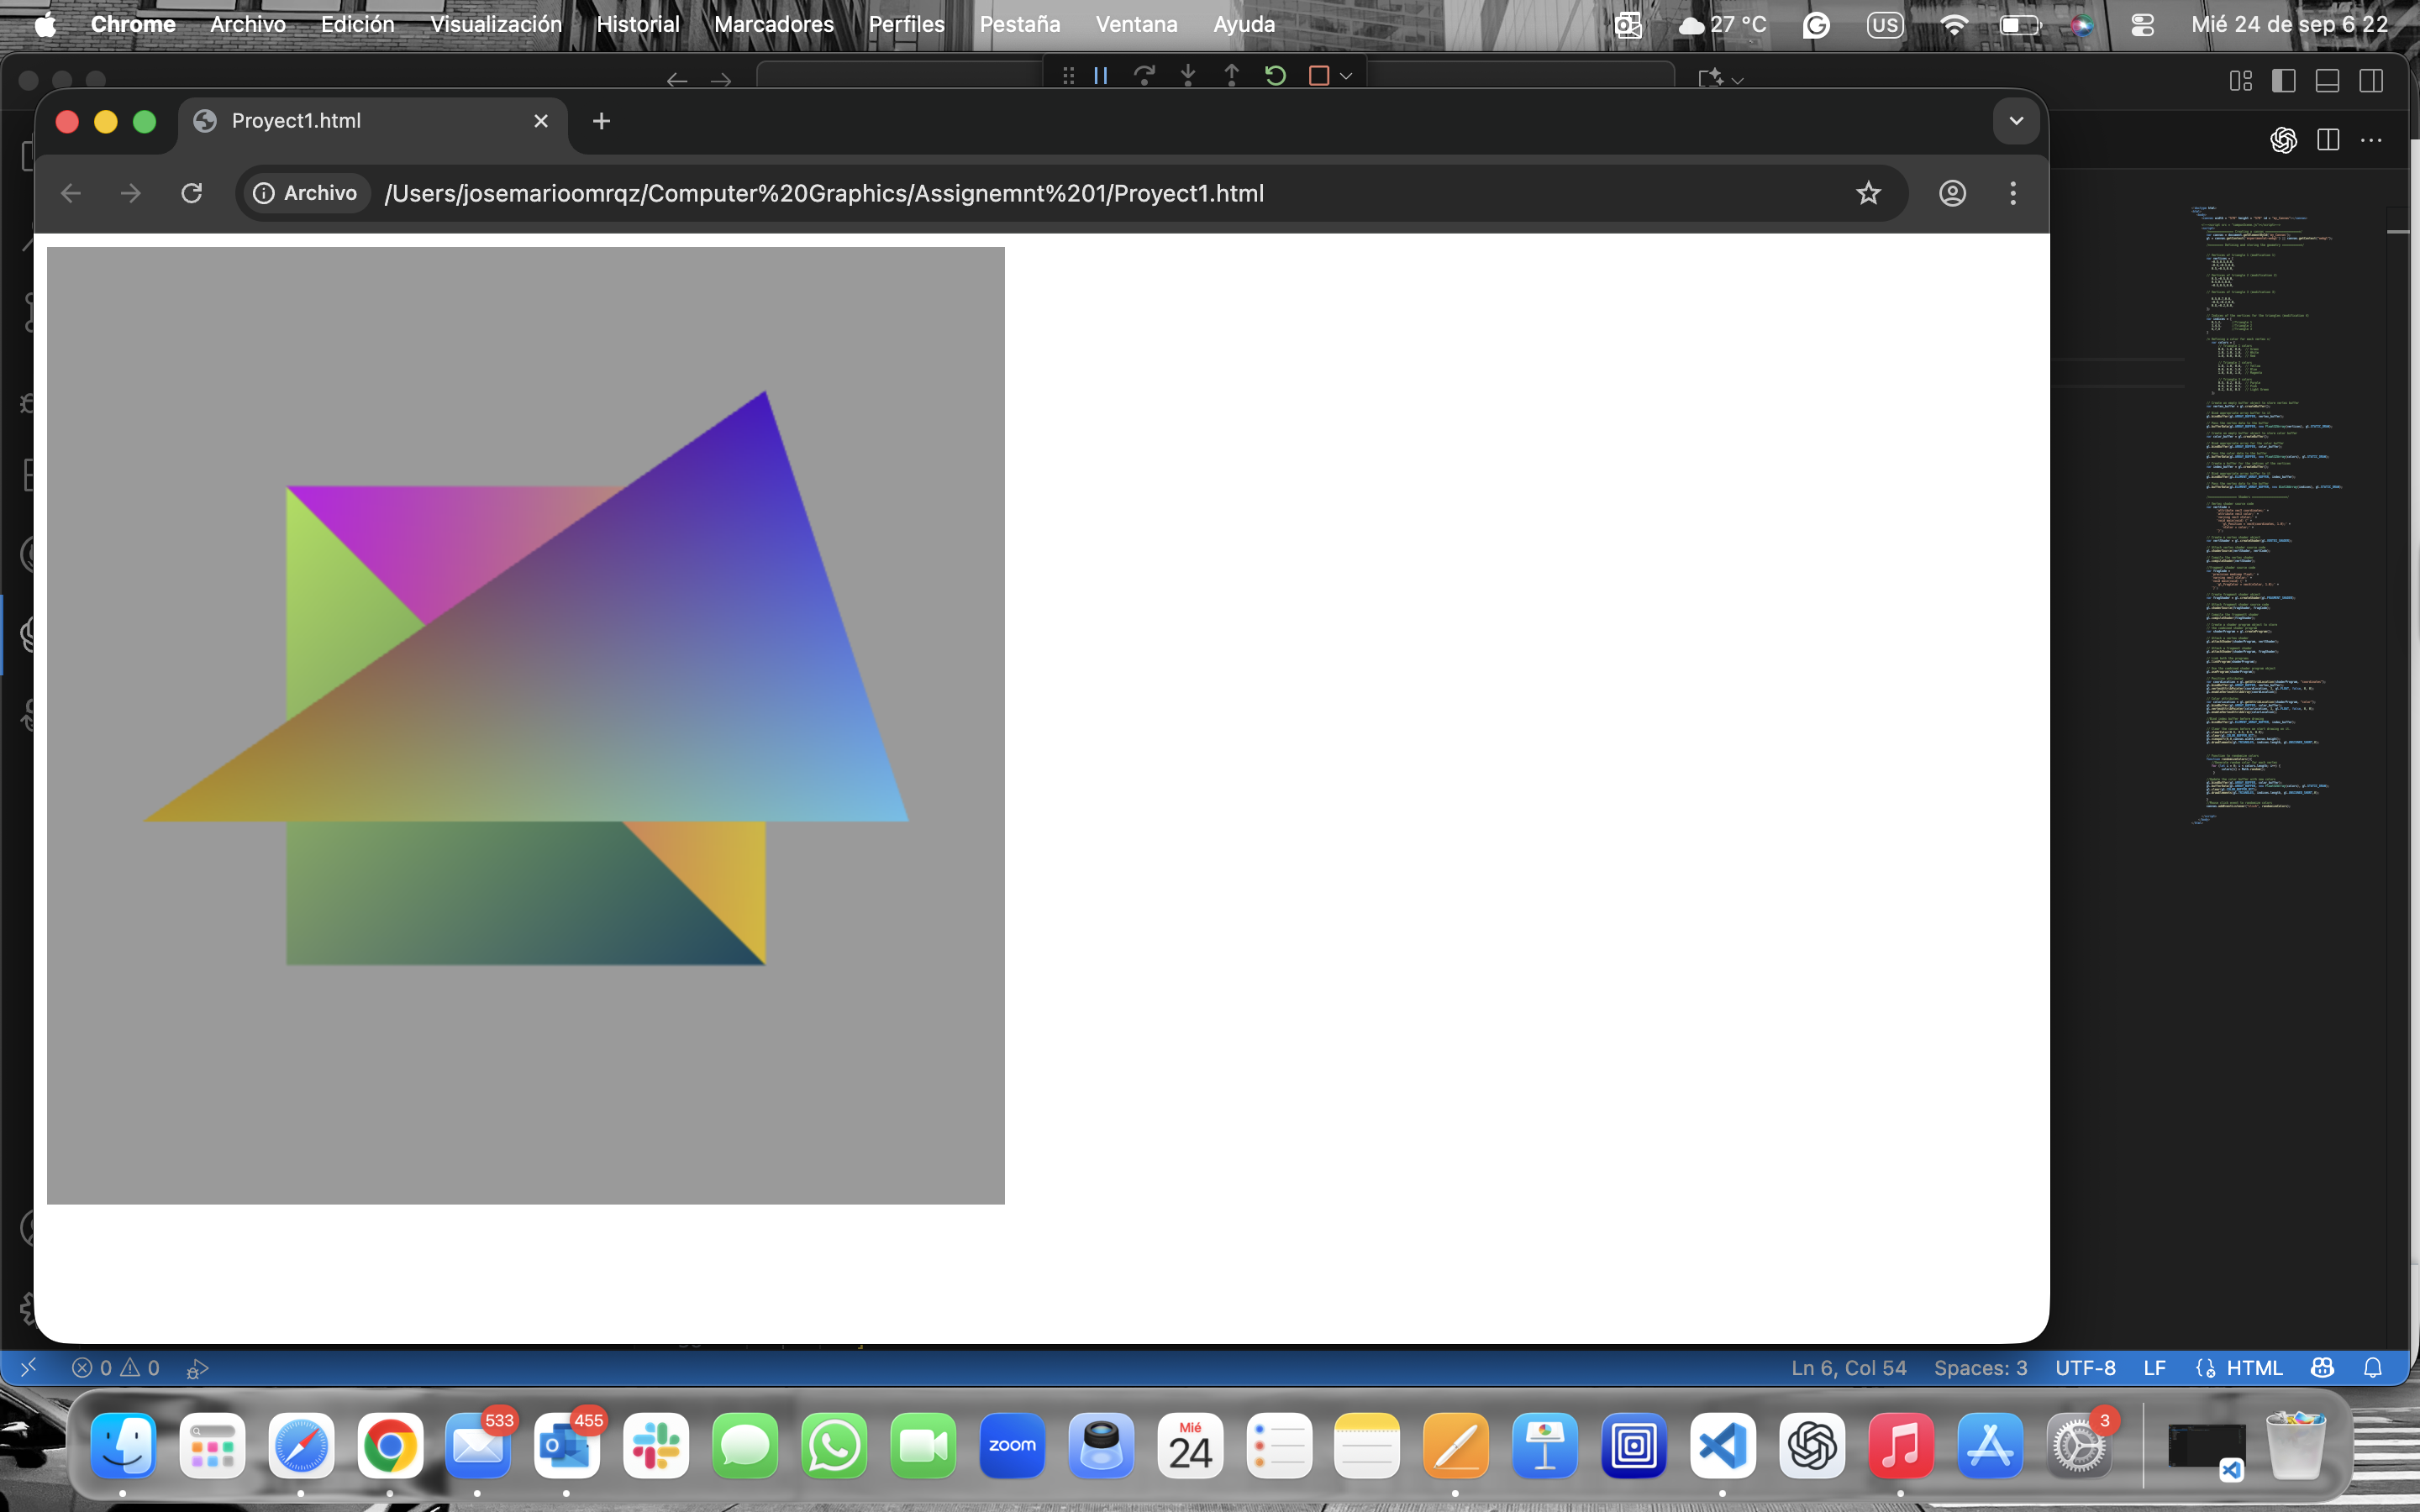

Part 3 - Results:

* Successfully was able to drew a simulation of the MSU Texas Tennis Center. Using the 3 triangles of part 2 as a starting point, I replaced triangle placeholders to make this 2D scene of the place I spend time every being a tennis student-athlete
* The challenges I faced were mostly the position of the vertex and coordinate edits, as well as adjusting the bathroom-door offsets, because they were primarily looking like windows. Also had to take off the random color function as well to simulate the brick red color of the tennis center building.
* My image consists of a brick red rectangle as the main building, along with a smaller more narrower rectangle as the roof. In this main building, we have a shed door (dark grey) and two smaller rectangular doors (light grey) simulating the men's and women’s bathrooms. At the top of these doors, we find another rectangle (white) simulating the “MSU Tennis Center” banner. Left of this building, there is a square (green) that simulates the drawing from a satellite view of the tennis courts.

- Spend around 20+ hours on this assignment. It was challenging, but one of the most interesting ones I had to do in my college career.

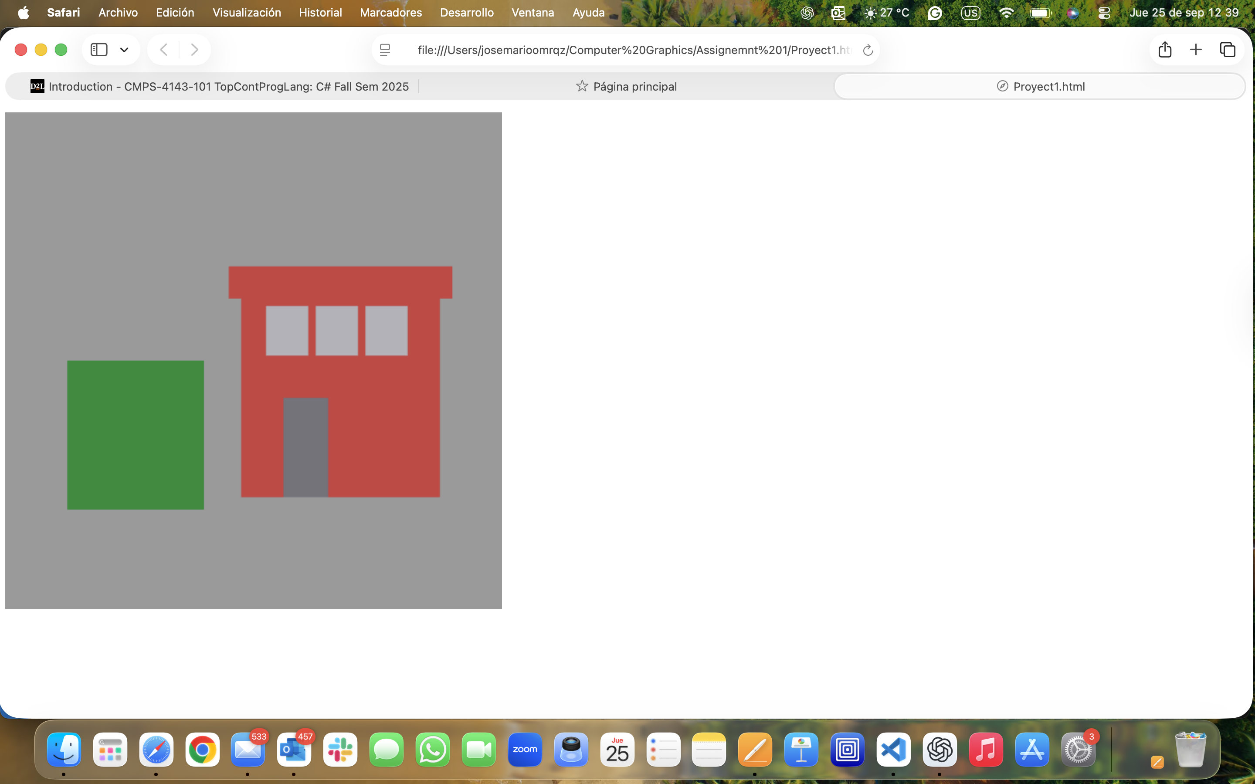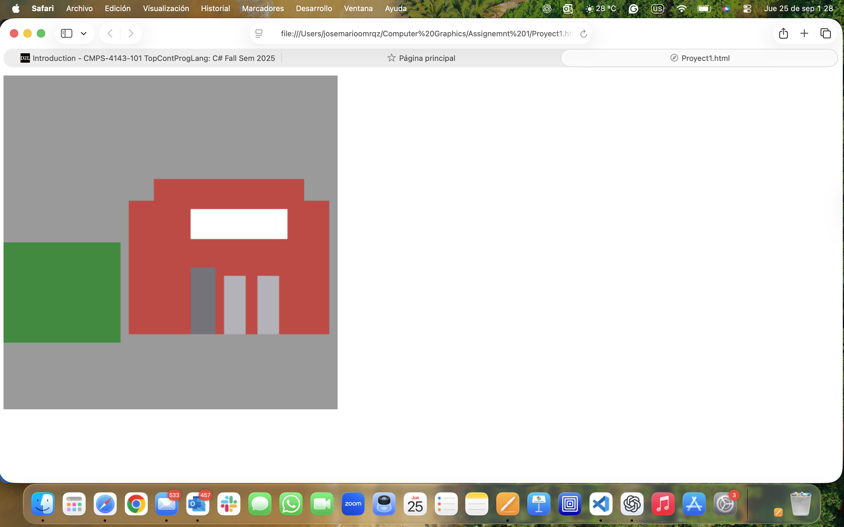

Experience & Challenges:

* Learned to work with the WebGL pipeline: shaders, buffers, and attributes.
* Debug shader compilation errors.
* Experimented with random colorization in triangles
* Confused about how to combine multiple shades into one scene.

Sources Used:

- WebGL Fundamentals: https://webglfundamentals.org/